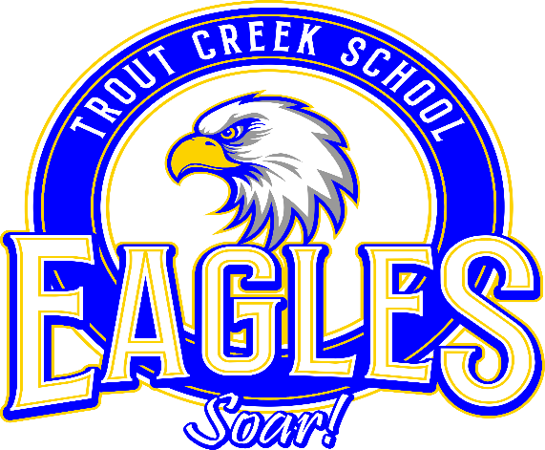

Boys Basketball Schedule
2022
DATE PLACE TIME
Oct 17 Practice Starts 3:30pm
Nov 5 Thompson Falls Jamboree TBA
Nov 8 Thompson Falls 4:00pm
Nov 10 Home vs Alberton 4:00pm
Nov 12 Hot Springs Jamboree TBA
Nov 15 Noxon 4:00pm
Nov 19 Alberton Jamboree TBA
Nov 22 Home vs Noxon 4:00pm
Nov 29 Plains 4:00pm
Dec 3 Trout Creek Jamboree TBA
(St. Regis & Hot Springs)
Dec 9&10 End of Season Tournament TBA
At Thompson Falls

*Schedule subject to change

